

Bill Analyzer Guide
High level
Version 1
10/9/2023

Contents
Getting Started 3
Home page 3
Statements 4-5
Reports 5
Bill analyst 6
Usage analyst 7
Orders 8
Setup 9-10
SFTP setup 10
Adding SFTP and Download formats 11
Help 12

Getting Started
Bill Analyzer is a comprehensive online bill presentation, reporting, and analysis tool designed to provide users with insight into their communications billing and usage. By viewing your invoices online and running simple reports, you can easily analyze your costs and usage to help you run your business more efficiently. Getting started is easy. From the moment you log in, you will have the ability to manage your invoices, view standard reports and graphs, and create your own custom reports. You can assign your accounts and services to your organization’s departments for quick cost allocation each month.

Home Page
The Home page contains Monthly spend, public notices, user information, “Help?”, customer support phone numbers, and report order information.
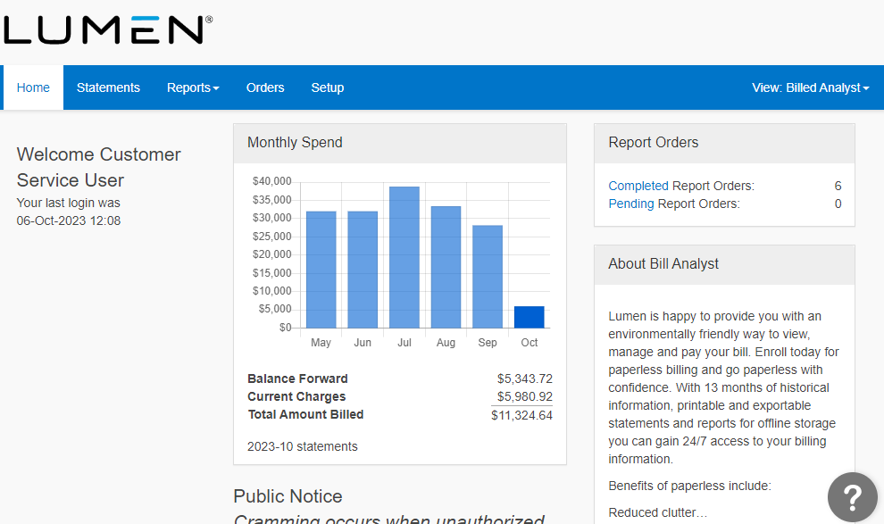

Statements
Viewing statements page contain the number of accounts, amount billed and selectable invoices. You can export a downloadable PDF or xml invoice data download for the current month or past invoices.
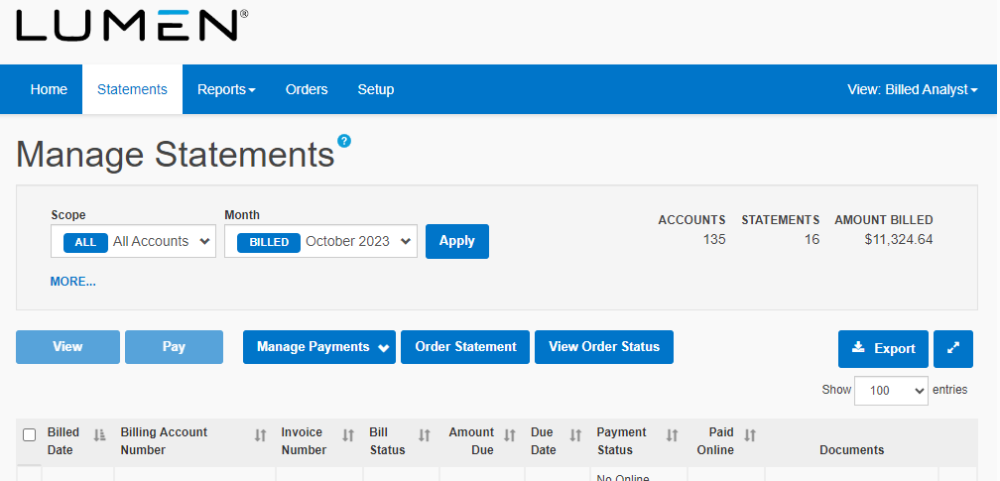

View a Single Statement
View a single invoice, in a summary or detail view. Use Scope, Month and additional filters to quickly find, group and view the accounts you want to see.
- From the top menu, click Statements.
- Under Month, select the statement month you want to view, and click Apply.
- To refine the list of accounts, use the sort and filter tools by selecting More, then Find and Group.
- Select the account number. A summary view of the statement appears.
- To see a detailed view, under Statement View, select Detail statement, and then click View.

View a Consolidated Statement
Statement consolidation allows you to group two or more statements together into a single, merged statement. You can also select all statements to consolidate them into a single, master statement for all accounts for the selected month.
- From the top menu, choose Statements.
- Under Month, select the billing month you want to view, and click Apply. To locate specific accounts, select More, and then the Group pull-down.
- Check the boxes next to the accounts you want to see, and then click View. A summary view of the statements from the selected accounts appears as one consolidated statement.
- To see a detailed view, under Statement View, select Detail statement, and then click View.

Compare Statements to Previous Months
You can compare current statements to historical statements to analyze cost and usage trends and identify variances month-over-month.
- From the top menu, click Statements.
- Check the box next to the accounts with the statements you want to compare.
- Click View.
- Under Compare, select up to 12 months of statements to compare.
- Click View.
- To see a detailed view, click Statement View, then select Detail Statement, and then click View.

Export a Single or Consolidated Statement
You can export single or consolidated statements in multiple file formats, to save or print for offline use.
- From the top menu, click Statements.
- Select a single statement, click View and then select Export.
- To export a consolidated statement, select multiple accounts from the statements list, and then select View. From Statement View, choose a Summary or Detail statement, and from Account Breakdown, choose Consolidate account charges or Break charges down by account. Then select Export.
- Choose the file format for the exported statement.
- Select PDF options for paper size and orientation.
- Click OK, and the exported statement will download, to save to file or print.

Reports For both BA (bill analyzer) and UA (usage analyst)
The reports section features multiple standard reports and graphs to help analyze your billing and usage data. You can view Cost Allocation reports to see a breakdown of expenditure across departments or regions. View Summary reports to get an overview of your telecommunications usage and costs, or view Detail reports for a more granular view of your data. Edit the reports that are provided, or create new ones that are specific to your business needs.
Reports provide a customized view of your statement activities.
Cost allocation reports present charges allocated across the organization by departments or locations. Bill Analyst only.
Summary reports present aggregated account data as interactive graphs or tables.
Detail reports present line by line charges, taxes and individual usage calls.
Run standard reports or create custom reports that meet your exact needs.
You can download your reports as needed or have them emailed to you on your schedule, by setting up report orders.

Bill Analyst
Bill Analyst also has multiple summary and detail reports to evaluate billing needs.
Users can edit, run, or delete canned reports they want to use or change. Users can copy an existing report and modify it as needed or add a totally new report.

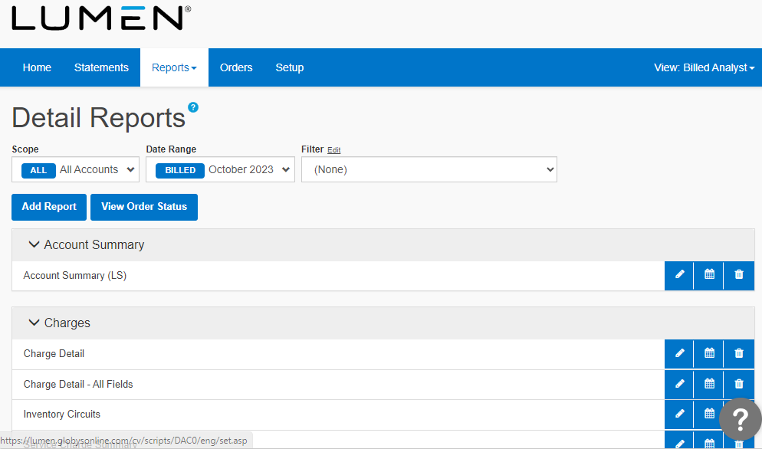

Usage Analyst
Usage analyst also has multiple summary and detail reports to evaluate usage needs.
Users can edit, run, or delete canned reports they want to use or change. Users can copy an existing report and modify it as needed or add a totally new report.

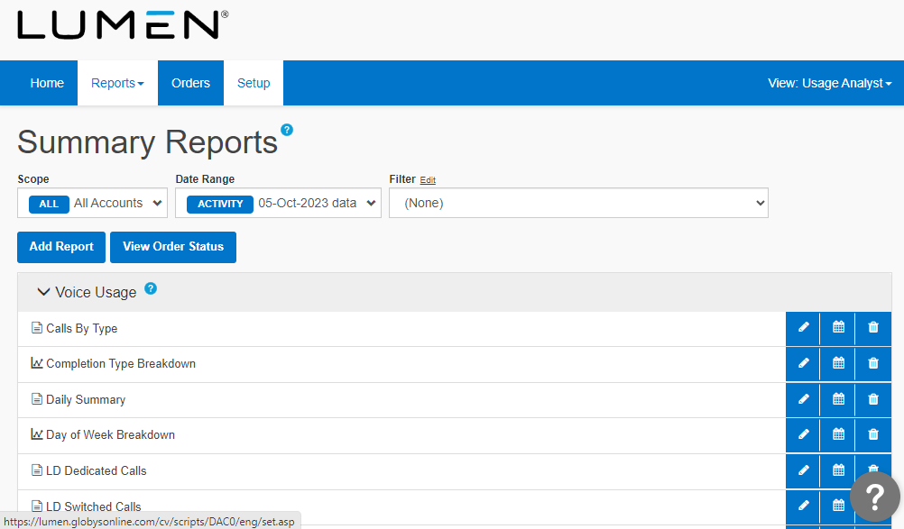

Orders
Orders are the number of reports and the amount of storage you as a customer have stored or are using. When an order is running it is either Pending or Completed and once orders have been completed, will show up at the bottom with the criteria you have selected, such as date, filters, account, and name of query.

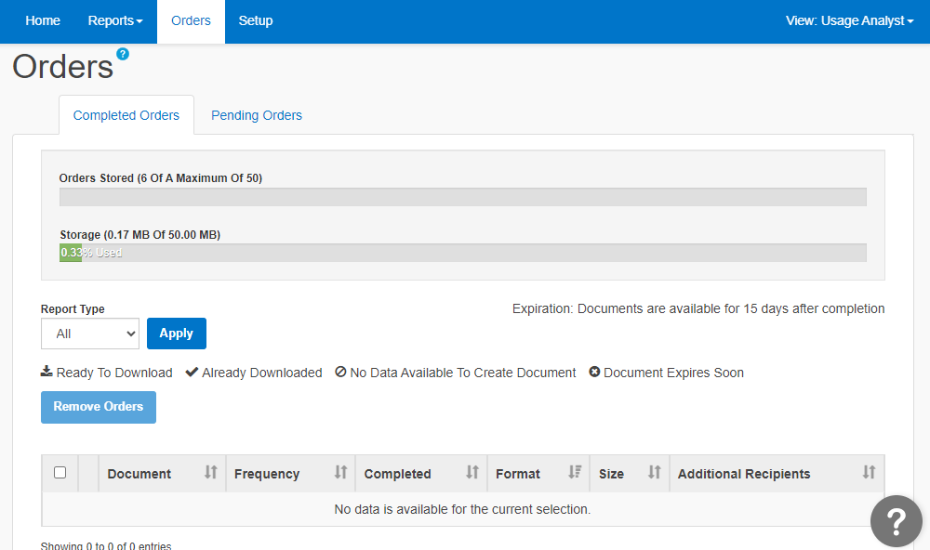
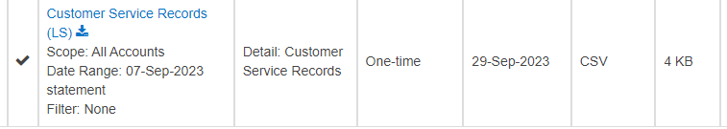

Setup
Setup is all the background information needed to make your queries meaningful. Under the help documents are all the listed documents to help you set up the hierarchy, tree builder, edit levels, descriptions, filters, regions, alerts, tools and SFTP locations.
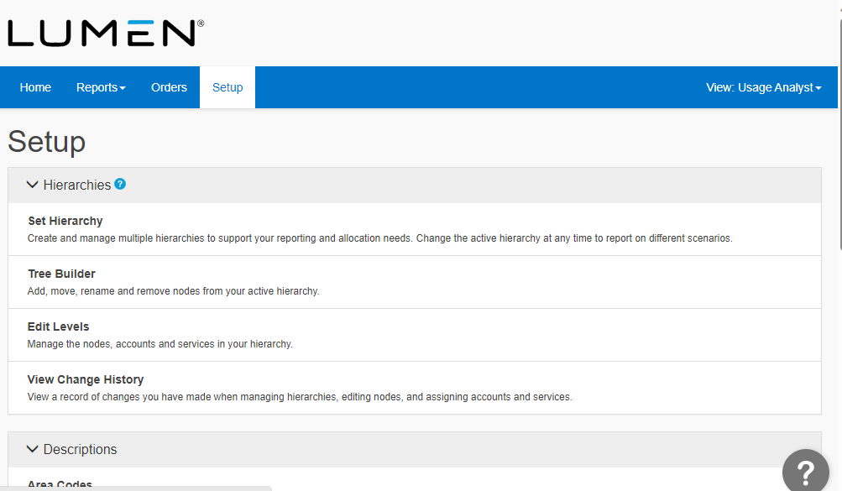
Setup Continued: 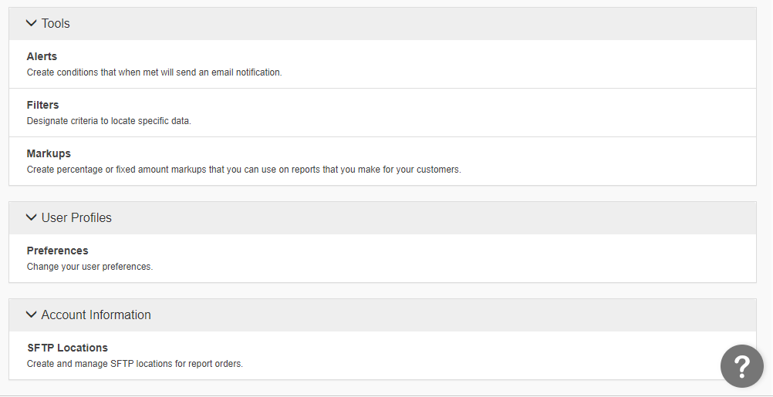

SFTP Locations
A user can Add, Edit or Remove a location.

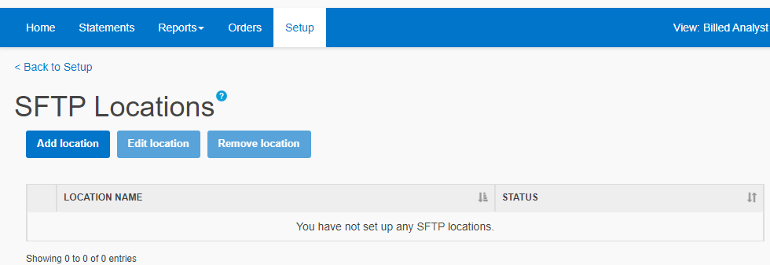

Adding a SFTP Location
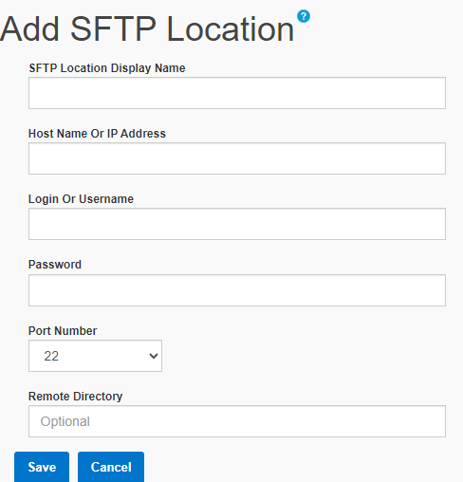

Documents can be downloaded in several formats.
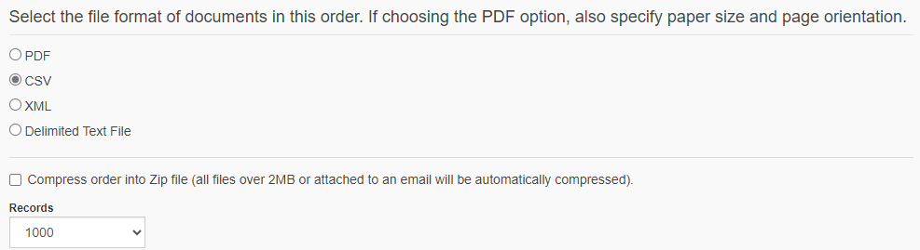

Help Documents
Select the “?” mark and easy help are there for your support.
